AWS Developer Associate

Lambda
There are 3 ways in which you can run them as HTTP/s endpoint:
- Register them as Target Group to an Application Load Balancer
- API Gateway
- Function URL
There will be sync call to Lambda in both these cases.
When we run it from ALB, there is a conversion of HTTP request to a JSON object. This is how it looks like:

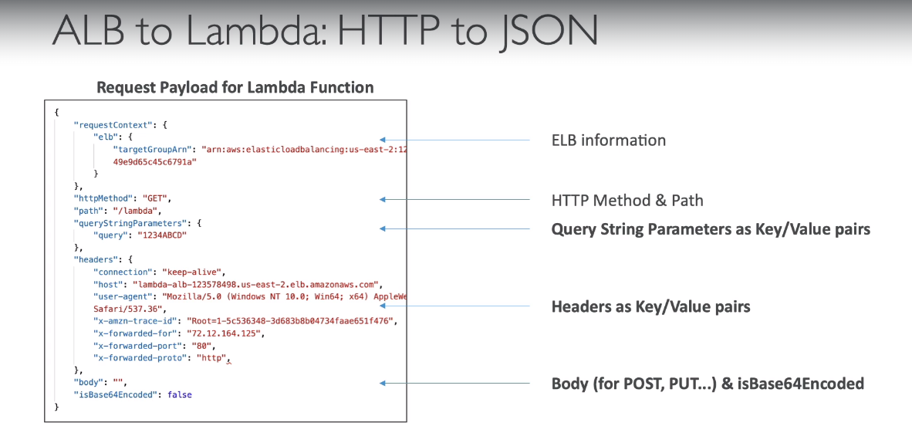
Similarly, since Lambda just returns JSON, there is a conversion from JSON to HTTP later.

If in our HTTP request from the client contains Multi-Header Value, for e.g same Key but different values in either HTTP Header or Query String, it is converted into an array in JSON object with same key.

The only reason you are able to call Lambda from ALB is because this Lambda has a Resource Based Policy which allows it to be invoked from ALB. (Remember there are 2 types of policies in AWS – Identity based and Resource based. Identity based policies are attached to IAM Role, Users and Groups. These policies let you specify what that identity can do. For e.g you can attach the policy to IAM user named John , stating that he’s allowed to perform the Amazon EC2 RunInstances action. Identity based policies can be managed or inline.
Resource based policies are attached to a resource. With these you can specify who has access to the resource and what actions can they perform on it. These policies are inline only, not managed. For e.g you can attach resource based policy to S3 buckets, DynamoDB tables, SQS queues.)

Sync vs Async Invocation
Sync – CLI, Sdk, Console, API Gateway, ALB
Async – S3 event notification, SNS, Cloudwatch Events/EventBridge, SES, CDK services

Async
In Async operations, events are placed in an Event Queue:
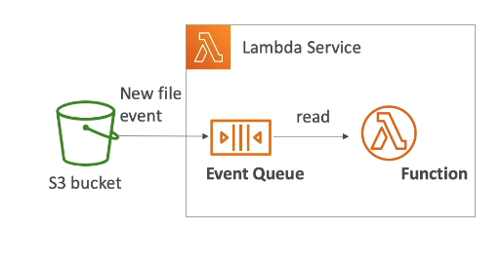
Lambda attempts to retry on errors:
- 3 tries total
- 1 minute wait after 1st try, then 2 mins wait
So important to make sure that Lambda functions are idempotent (in case of retries).
There will also be duplicate entries in cloudwatch logs.
Can define DLQ – SNS or SQS – for failed processing (need correct IAM permissions)

Triggering Lambda
There are broadly 2 ways in which Lambda can be run automatically:
Direct Triggers: Some services can directly invoke Lambda function using triggers. These services push events to Lambda, and the function is invoked immediately when the specified events occurs. They are suitable for real time processing and discrete events. Here, the trigger is actually stored and managed by the service that generates the events, not by Lambda. E.g S3, SNS, API Gateway.
Event Source Mappings: These are Lambda resources created and managed within the Lambda service. These are designed for processing high volume streaming data or msgs from queues, where polling of events is done by the Lambda. Eg SQS, DynamoDB, Kinesis
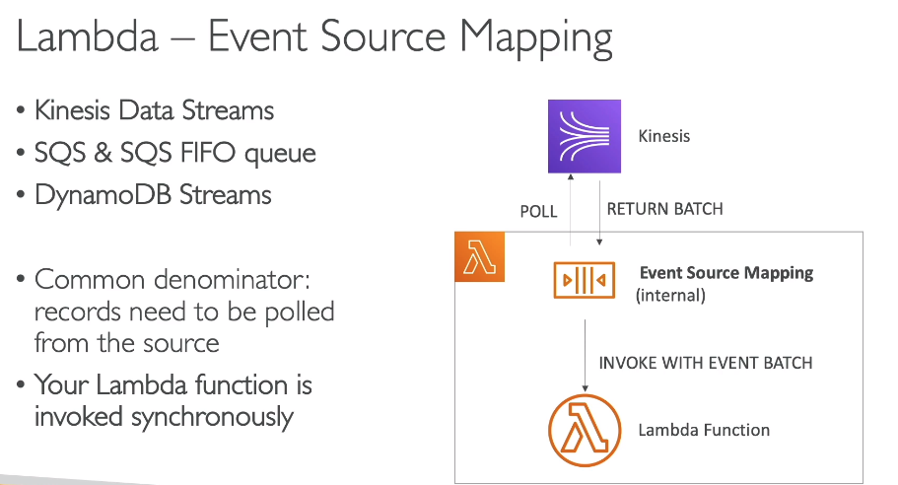

S3 Event Notification Types which may Invoke Lambda
S3:ObjectCreated, S3:ObjectRemoved, S3:ObjectRestore, S3:Replication
Object Name filtering (eg *.jpeg)
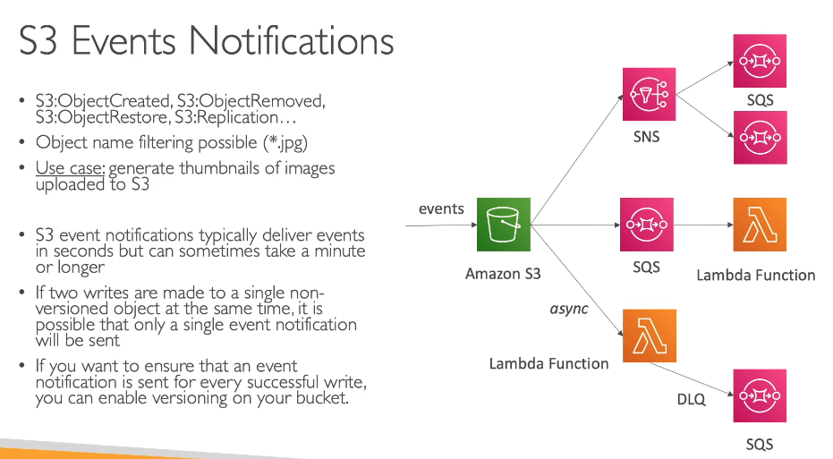
Lambda Execution Role (IAM Role)
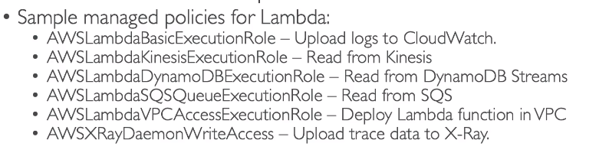
It grants the Lambda function permissions to AWS services/resources.
When we use Event source mapping to invoke our function, Lambda uses the execution role to read event data.
Best Practise: Create one execution role per Lambda function.

Lambda Resource Based Policies
Use this to give other accounts and AWS Services permission to use your lambda.
In case of direct triggers, we need to have Resource Based policies.
This is similar to S3 bucket policies.

VPC Concepts with Lambda
By default, lambda function is launched outside your own VPC (in an AWS owned VPC). Therefore, it cannot access resources in your VPC (RDS, EC2, internal Load balancer)

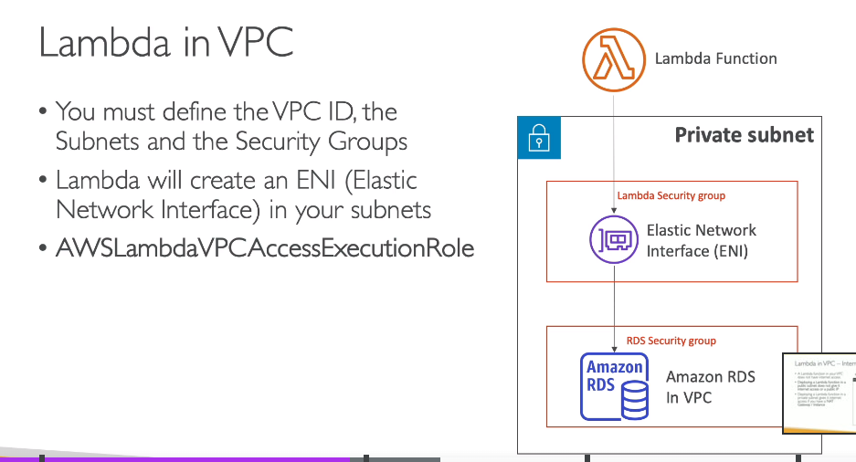
But when we create a Lambda in a VPC, it doesn’t have internet access. Infact, even if we create a Lambda in public subnet, it won’t have internet access and a public IP. But cloudwatch still works.

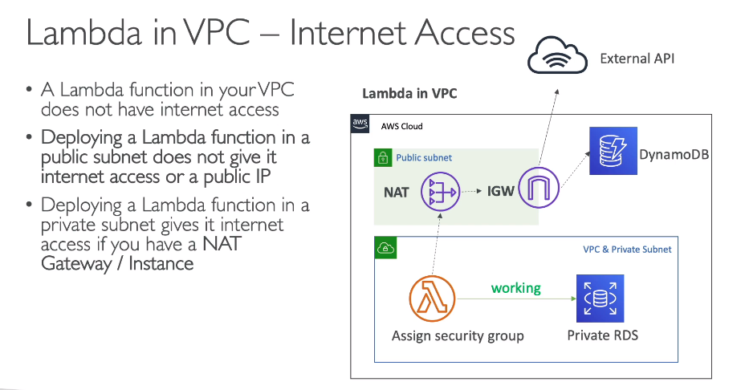
In above workflow, if you want to connect to DynamoDB from Lambda privately, use VPC endpoints.

Lambda Execution Context
It is a temp runtime that initializes any external dependencies of your lambda code.
It’s great to do any DB connections, HTTP clients, SDK clients.
The EC is maintained for sometime in anticipation of another Lambda invocation. So the next function invocation can re-use the context and save time in initializing objects.
The EC includes a /tmp directory to store temporary directories.
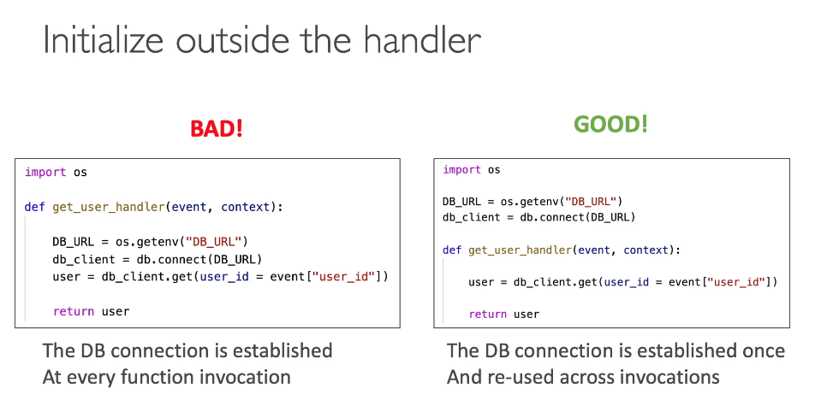
Concurrency
Generally, concurrency means the ability of a system to process more than one task simultaneously. In AWS Lambda, Concurrency is the number of in-flight request that your function is handling at the same time.

Refer - https://docs.aws.amazon.com/lambda/latest/dg/lambda-concurrency.html#:~:text=As%20your%20functions%20receive%20more%20requests%2C%20Lambda,across%20all%20functions%20in%20an%20AWS%20Region.

Concurrency Limit
Default concurrency limit for AWS Lambda is 1000 concurrent executions across all functions in a Region. We can request a quota increase and also configure function level concurrency controls so that our cricical functions are not throttled.
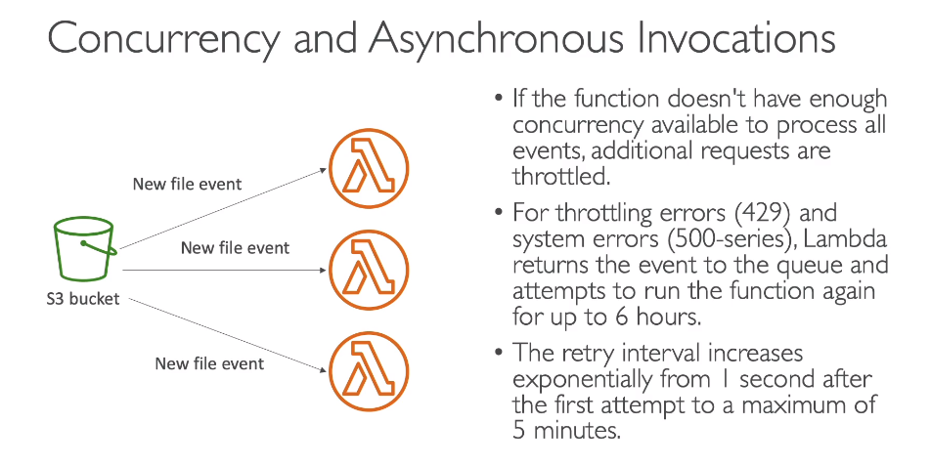
There are 2 types of concurrency

Deploy Code to Lambda
There are 3 ways in which you can deploy code to Lambda function:
- Direct Code (Only for interpreted languages like Python and NodeJS)
- Zip packages (of binaries of compiled languages)
- Container Images (The base image must have Lambda

Lambda Layers
A lambda layer is a .zip file archive that contains supplementary code and data/packages. They usually contain library dependencies, a custom runtime, or config files.
These are few reasons to use lambda layers:
- reduce size of deployment package
- separate core function logic from dependencies
- share dependencies across multiple function

You can attach upto 5 layers per lambda function. Also you can use layers only with lambda functions deployed as .zip archive. For functions defined as a container image, package your preferred runtime and all code dependencies when you create container image.

When you add a layer to a function, Lambda extracts the layer contents into the /opt directory of your function’s execution environment.

Maximum size of a layer could be 250 MB.

External Dependencies
If your code has external dependencies like Database Client etc, you need to install the packages alongside your code and zip it together.
Upload the zip directly to Lambda if it’s less than 50 MB, else to s3 first.
AWS SDK by default with every lambda function.

Using Lambda Layers vs Deployment Package using zip
Layers are usually used when you have some depedencies which are common across multiple lambda functions. If your dependency size is small and is used by 1 function only, then use zip approach.
In layers, the dependencies are added to /opt folder of execution environment.

Lambda Limits
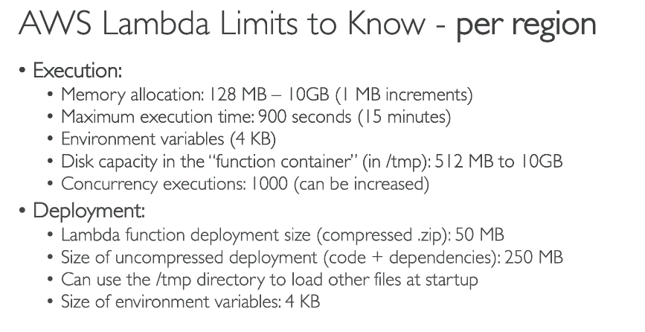

Check how we specify starting file when lambda is uploaded as a zip

Lambda Container Image vs ECS on Fargate

